
Shareholder Agahi – Your Gateway to Shareholder Insights
Pakistan’s first comprehensive platform, developed by PICG and CDC, dedicated to enhancing shareholder awareness and empowerment.
Discover Shareholder Agahi- Your one-stop hub for real-time shareholder updates, rights, and governance insights. Empower yourself with accurate information.
Explore the portal: https://www.shareholderagahi.com/

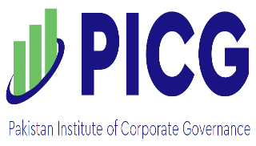
Watch the tutorial (Urdu): https://www.youtube.com/watch?v=O7iCRiKJ37A

